**Department of Mechanical and Industrial Engineering**

Please select your current program below:

* **~~Mechanical Engineering~~**
* **Industrial Engineering**

| Course Number | MEC 809 |
| --- | --- |
| Course Title | Integrated Manufacturing |
| Semester/Year | Winter 2022 |
| Instructor | Siyuan He |
| Section Number | 04 |

| **Project Report No. 1** | |
| --- | --- |

| Report Title | Robot Manipulator for Relocating Parts with Teaching Function |
| --- | --- |
| Group Number | 4 |
| Submission Date | 2022-04-18 |
| Due Date | 2022-04-18 |

| Student Name | Student ID (xxxx1234) | Signature* |
| --- | --- | --- |
| Ryan Chen | xxxx90697 | R.C. |
| Trevor Chao | xxxx21051 | T.C |
| Osama Muhammad | xxxx23376 | O.M |
| Yuenong Guo | xxxx08512 | K.G |

(Note: Remove the first 4 digits from your student ID)

*\*By signing above you attest that you have contributed to this submission and confirm that all work you have contributed to this submission is your own work. Any suspicion of copying or plagiarism in this work will result in an investigation of Academic Misconduct and may result in a “0” on the work, an “F” in the course, or possibly more severe penalties, as well as a Disciplinary Notice on your academic record under the Student Code of Academic Conduct, which can be found online at:* [*http://www.ryerson.ca/senate/policies/pol60.pdf*](http://www.ryerson.ca/senate/policies/pol60.pdf)*.*

# Abstract

The use of robotics in manufacturing is continuously growing and the need to understand the process of using robots as well as programming them is becoming more and more popular in today’s work environment. The main benefit of using robotics for manufacturing is a smaller margin of error for doing repetitive tasks where people can become exhausted from. Using a Lego Mindstorm kit, the group is able to create and program a robot to replicate what would be done in a regular day of work in a manufacturing plant. For a robot to move an object from one place to another with machine learning to fully automate the movement from picking up the object to slowly placing the object. Through the successful creation of the group, the final design was able to follow instructions by learning the locations of the two tires and picking up and dropping the ball in the correct location.

# Table of Contents

**Abstract** **1**

**Table of Contents** **2**

**Introduction** **3**

**Problem Definition** **4**

**Solution and Implementation** **5**

Control Method/Strategy Used 5

Hardware improvement 5

List of Sensors/Actuators Used 7

Software Flowchart 8

**Team Member Roles** **9**

**Conclusions and Recommendations** **10**

**References** **11**

**Appendix: Program Listings** **12**

# Introduction

The purpose of this project is to design, build and code a robot manipulator that is capable of relocating a ball from one location to another. The robot manipulator is created using the parts provided in a Lego Mindstorms Robot Kit, and controlled with an Arduino Uno with an EVShield. The Lego kit provides 3 servo motors, 1 touch sensor, 7 I/O cables and an ultrasonic distance sensor. The device is powered by a rechargeable battery or external power source (i.e. PC). For this project, the 3 servo motors, the touch sensor and 4 I/O cables will be used, along with plastic lego pieces and connectors.

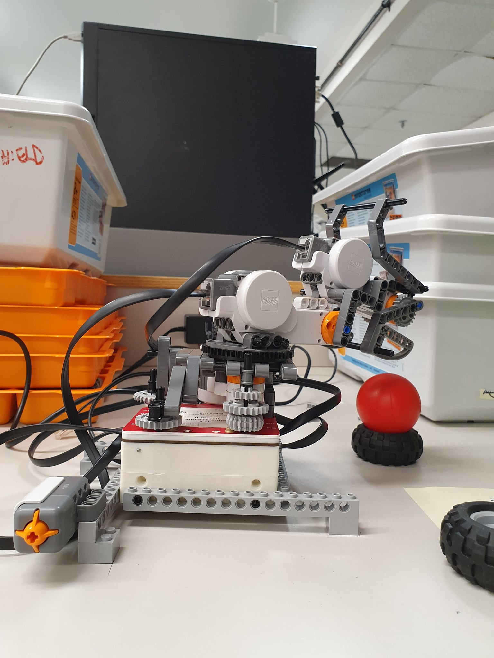

Figure 1. The final robot manipulator design

The ball is to be placed on a tire at Location A and moved to another tire at Location B. The robot will be taught the locations using an input touch sensor. The robot will consist of two joints and a gripper that is able to open/close its fingers.

# Problem Definition

Guidelines provided in the project outline are employed to better comprehend the design requirements of the robot manipulator.

* The robot must consist of a robot arm and an end-effector to grab the ball
* The robot arm will contain 2 joints, while the end effector will be a gripper
* The robot is taught the two locations of A and B by manually moving the end-effector to both locations
* An input touch sensor is used to teach the robot the positions of Location A and B
* The robot manipulator must have a work envelope that is greater than 15cm
* The ball is placed on a tire at Location A and B

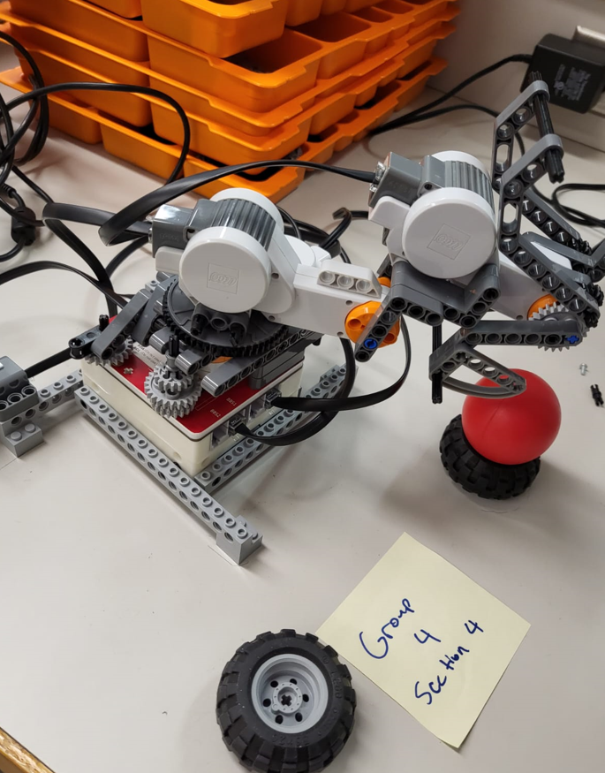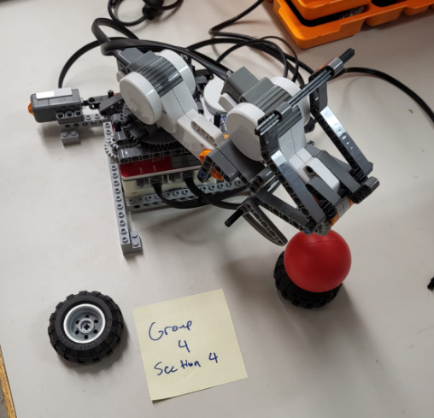

Figure 2. Locations A and B with respect to the robot

# 

# Solution and Implementation

## Control Method/Strategy Used

The strategy used to control the robot arm was to constantly read the encoder values provided by the interactive servo motors in order to determine the position of the robot arm at all times. This allowed the robot to save the positions of location A and B by saving the degrees at which each motor turned from an initial starting position from reading the encoder values. After moving the robot to each location A and B, a pushing the touch sensor will save each degree moved from each servo motor to get the horizontal and vertical position of the end effector. When executing the movements to pick up the ball, it is hard coded to move to specific positions by subtracting the difference between the two locations in order to move the end effector into the desired location for moving the ball and if slight errors occur due to things like play in the motor or slightly inaccurate encoder values, it will be accounted for within the code by adding adjustment values.

## Hardware improvement

Initially, the size of the robot base only consisted of the area of the Arduino Uno and EVshield. This was a concern as the area was small given the required work envelope in the project manual. This small area at the base of the robot will cause the robot to tip over as the height and length of the arm increases. Thus, four 16x1 pieces were added to the sides of the base to ultimately increase the area similar to an outrigger of a crane truck.

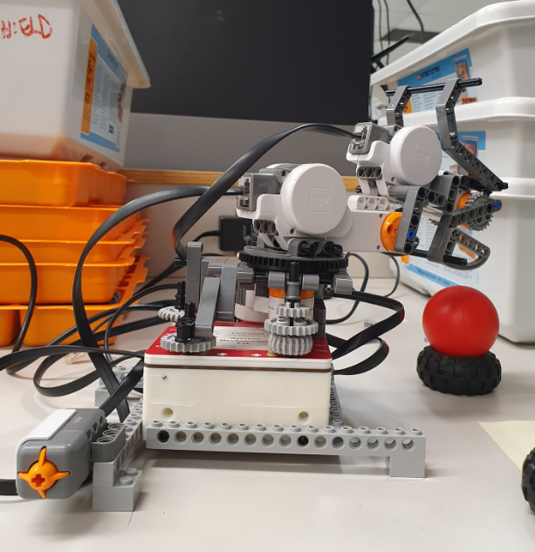

Figure 3. The final design for the base of the robot manipulator

With the first motor secured horizontally on the base of the robot, the second motor which controls the up and down movement of the gripper was attached to the first motor with a few blocks, however this caused the gripper to be too far away from the body, leading to the second motor lifting away from the first motor, as well as causing problems with the clearance of the cables. Therefore a more anchored way of attaching the second motor to the first was to use a planetary gear to transfer the motion while keeping the second motor directly above the first motor.

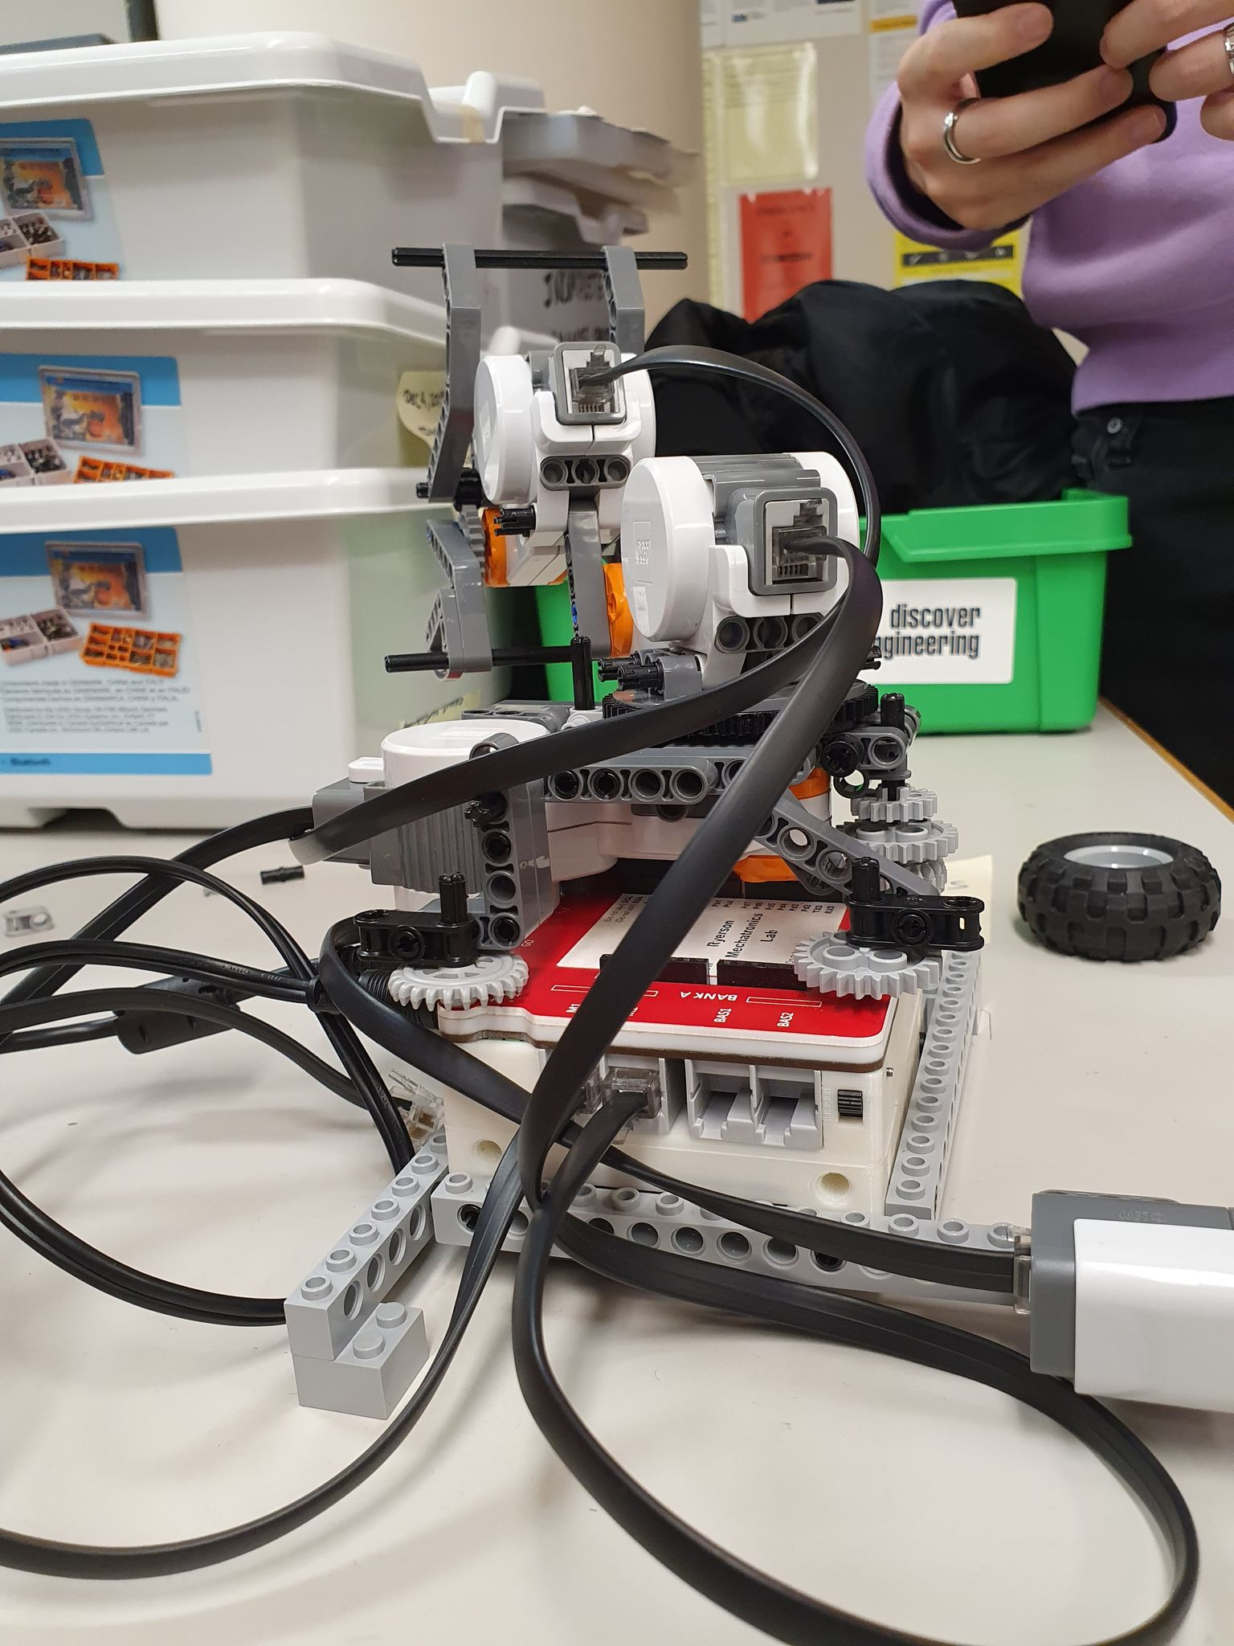

Figure 4. Final revision to horizontal and vertical motor mount

At joint 2, the connection arm between the second motor and the gripper motor was too long, causing the gripper motor to pitch down at rest due to its weight, as well as causing problems with the angle of the gripper respective to the ball. The solution to this was to shorten the arm, moving the weight of the gripper closer to the body without sacrificing clearance.

The initial gripper consisted of a single moving finger. This led to a small grasp area as well as the fixed finger hitting the ball away from the tire during motion before grasping. The gripper was then improved to having two movable fingers connected with gears to allow the two fingers to fully open and thus creating a larger grasping area.

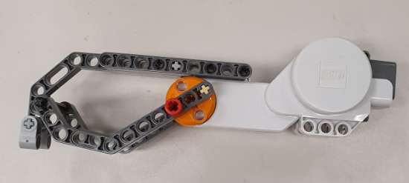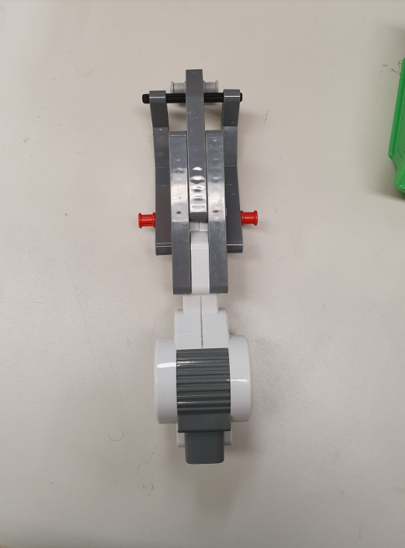

Figure 5. Initial gripper/end effector design

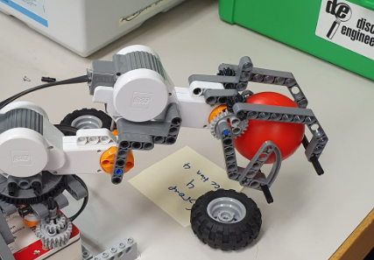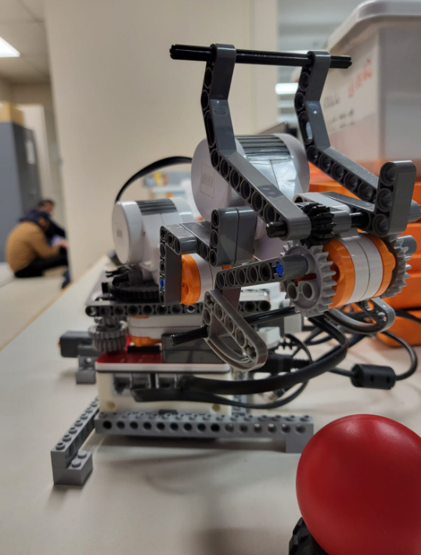

Figure 6. Final gripper/end effector design

## List of Sensors/Actuators Used

* 1x Lego Mindstorms Touch Sensor Item # 9843
* 3x Lego Mindstorms Interactive Servo Motor Item # 9842

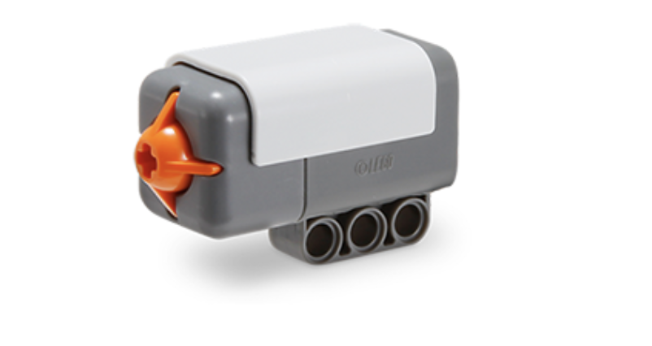

Figure 7. Lego Mindstorms Touch Sensor [1]

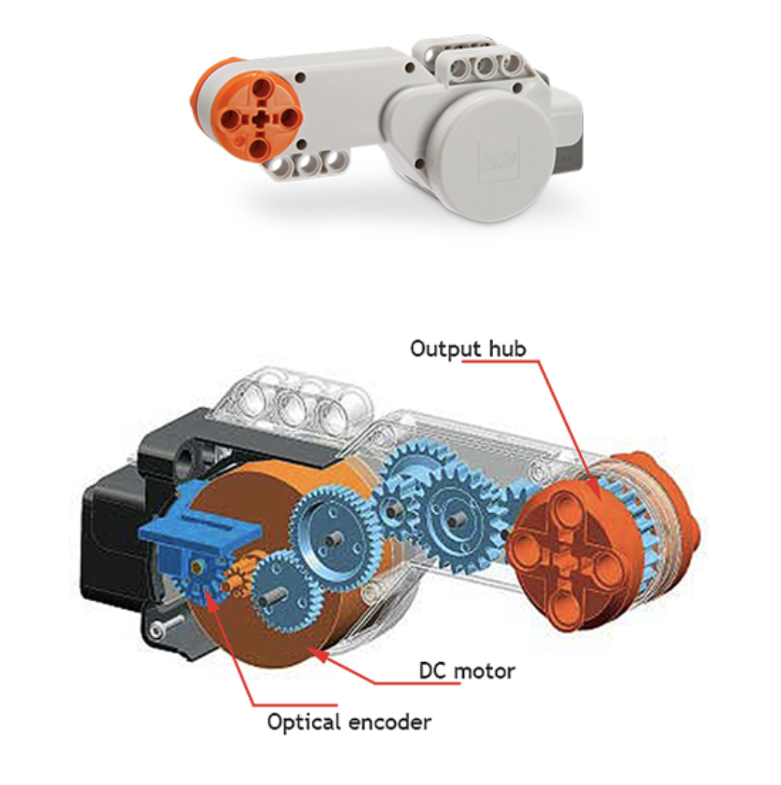

Figure 8. Lego Mindstorms Servo Motor [1]

## Software Flowchart





Figure 9. Software flowchart of the robot manipulator

# Team Member Roles

|  | Team Member Roles / Tasks Completed |
| --- | --- |
| Ryan Chen | * Program and troubleshoot the robot functions * The construction of the robot * Edits to the final project report |
| Trevor Chao | * The construction of the robot * Assisted with testing the code * Edits to the final project report |
| Osama Muhammad | * The construction of the robot * Edits to the final project report |
| Yuenong Guo | * The construction of the robot * Edits to the final project report |

# Conclusions and Recommendations

In conclusion, the experiment was demonstrated successfully. The robot successfully read and memorized the intended grasping and release locations, and performed the task to a great extent. During the design process, a few issues were encountered with both the hardware and software. The robot initially experienced instability due to a small base area, as well as clearance issues with motors and wires, furthermore the grasp area of the gripper was too small. As for the software, coding errors occurred such as sudden drops of the claw and the inability to move unless its rotations were met.

These issues were resolved for the final demonstration. The initial demonstration resulted in a failure due to the end effector knocking the tire and ball over during the grasping motion. The error was determined to be a low placement of the gripper during the “learn” stage of the process, and as the gripper initiated the grasping motion, the finger pushed the tire and ultimately knocked the ball over. The failure was corrected for the second demonstration by placing the gripper slightly higher during the “learn” stage, so the fingers have enough clearance to the tire when grasping, which resulted in a successful demonstration.

# References

[1] https://www.smashingrobotics.com/getting-started-with-mindstorms-nxt/

# Appendix: Program Listings

Below is the code for the following program: **MEC809_ProjectCode.ino**

| #include <Wire.h> #include <EVShield.h> #include <EVs_NXTTouch.h>   // setup for this example: // horizontal motor: bank A, M1 // vertical motor: bank A, M2 // gripper motor: bank B, M1 // touch sensor: bank B, BBS1  // Open the Serial terminal to view.  // declare the EVShield(s) attached to your Arduino. EVShield evshield(0x34, 0x36);  // declare the i2c devices used on EVShield(s).  // declare analog devices attached to evshields.    int press_counter = 0; int32_t posA1, posA2, posB1, posB2; int motor_speed = 70, gripper_degree = 130, offset_error_horizontal = 50;  EVs_NXTTouch touch1;  void setup() {  char str[256];   Serial.begin(115200); // start serial for output  delay(500); // wait, allowing time to activate the serial monitor   Serial.println ("Initializing the devices ...");   // EVShield provides multiple protocols  // Initialize the protocol for EVShield  // It is best to use Hardware I2C (unless you want to use Ultrasonic).   //evshield.init( SH_SoftwareI2C );  evshield.init(); // the default is SH_HardwareI2C   // Wait until user presses GO button to continue the program  Serial.println ("Turn the motor shaft to see changing encoder values.");  Serial.println ("Press Left Arrow button to reset motor encoder.");  Serial.println ("---------------------------");  Serial.println ("Press GO button to continue");  Serial.println ("---------------------------");  while (!evshield.getButtonState(BTN_GO)) {  if (millis() % 1000 < 3) {  Serial.println("Press GO button to continue");  }  }   // Initialize the i2c sensors.   // initialize the analog sensors.  touch1.init( &evshield, SH_BBS1 );   // reset motors.  evshield.bank_a.motorReset();  evshield.bank_b.motorReset(); }  int32_t new_encoder1, new_encoder2, new_encoder3; //was outside the setup function in 'MotorEncoder' example  void loop() {  char aa[80];  int a;  char str[256];  bool touch_status;  bool last_status;    delay (1000);  new_encoder3 = evshield.bank_b.motorGetEncoderPosition(SH_Motor_1); //motor for gripper  new_encoder2 = evshield.bank_a.motorGetEncoderPosition(SH_Motor_2); //motor for vertical  new_encoder1 = evshield.bank_a.motorGetEncoderPosition(SH_Motor_1); //motor for horizontal    sprintf (str, "encoder values: 1) %ld, 2) %ld, 3) %ld", new_encoder1, new_encoder2, new_encoder3);  Serial.println (str);  str[0] = '\0';   a = touch1.readRaw(); // reads if the status of the touch sensor   touch_status = touch1.isPressed(); // places a boolean value for 'touch_status'  // 'sprintf' is a more efficient way to print multiple things instead of using multiple 'Serial.print()'s   sprintf (str, "touch1: is pressed : %s\nButton Counter: %d", touch_status ? "true" : "false", press_counter);  Serial.println(str);  str[0] = '\0';   if ( touch_status != last_status ) {  if (touch_status) {  press_counter++;  delay(1000);  str[0] = '\0';   switch (press_counter) {  case 1: //save posA after first button press  posA1 = new_encoder1;  posA2 = new_encoder2;   str[0] = '\0';  sprintf (str, "case 1 encoder values: 1) %ld, 2) %ld", posA1, posA2);  Serial.println(str);  break;  case 2: //save posB after second button press  posB1 = new_encoder1;  posB2 = new_encoder2;   str[0] = '\0';  sprintf (str, "case 2 encoder values: 1) %ld, 2) %ld", posB1, posB2);  Serial.println(str);  break;  case 3: //run automatic movement after third button press  press_counter = 0;  sprintf (str, "case 3 posA: 1) %ld, 2) %ld, posB: 1) %ld, 2) %ld, ", posA1, posA2, posB1, posB2);  Serial.println(str);   //opens gripper  //evshield.bank_b.motorRunDegrees(SH_Motor_1, SH_Direction_Reverse, motor_speed, 130, SH_Completion_Wait_For, SH_Next_Action_BrakeHold); //gripper motor opens  //delay(1000);   //move upwards  evshield.bank_a.motorRunDegrees(SH_Motor_2, SH_Direction_Forward, motor_speed, 60, SH_Completion_Wait_For, SH_Next_Action_Brake); //vertical motor  delay(1000);   //move to posA  evshield.bank_a.motorRunDegrees(SH_Motor_1, SH_Direction_Forward, motor_speed, posA1 - posB1 + offset_error_horizontal, SH_Completion_Wait_For, SH_Next_Action_Brake); //horizontal motor  delay(1000);  evshield.bank_a.motorRunDegrees(SH_Motor_2, SH_Direction_Forward, motor_speed, posA2 - posB2, SH_Completion_Wait_For, SH_Next_Action_Brake); //vertical motor  delay(1000);   //move downwards  evshield.bank_a.motorRunDegrees(SH_Motor_2, SH_Direction_Reverse, motor_speed-30, 40, SH_Completion_Wait_For, SH_Next_Action_Brake); //vertical motor  delay(1000);   //closes gripper  evshield.bank_b.motorRunDegrees(SH_Motor_1, SH_Direction_Forward, motor_speed, gripper_degree, SH_Completion_Wait_For, SH_Next_Action_Brake); //gripper motor closes when fully open  delay(1000);   //move upwards  evshield.bank_a.motorRunDegrees(SH_Motor_2, SH_Direction_Forward, motor_speed, 60, SH_Completion_Wait_For, SH_Next_Action_Brake); //vertical motor  delay(1000);   //move to posB  evshield.bank_a.motorRunDegrees(SH_Motor_1, SH_Direction_Reverse, motor_speed, posA1 - posB1 + offset_error_horizontal, SH_Completion_Wait_For, SH_Next_Action_Brake); //horizontal motor  delay(1000);  evshield.bank_a.motorRunDegrees(SH_Motor_2, SH_Direction_Reverse, motor_speed, posA2 - posB2, SH_Completion_Wait_For, SH_Next_Action_Brake); //vertical motor  delay(1000);   //move downwards  evshield.bank_a.motorRunDegrees(SH_Motor_2, SH_Direction_Reverse, motor_speed-30, 40, SH_Completion_Wait_For, SH_Next_Action_Brake); //vertical motor  delay(1000);   //opens gripper  evshield.bank_b.motorRunDegrees(SH_Motor_1, SH_Direction_Reverse, motor_speed, gripper_degree, SH_Completion_Wait_For, SH_Next_Action_Brake); //gripper motor opens  delay(1000);   //move upwards  evshield.bank_a.motorRunDegrees(SH_Motor_2, SH_Direction_Forward, motor_speed, posA2 - posB2 + 50, SH_Completion_Wait_For, SH_Next_Action_Brake); //vertical motor  delay(1000);   break;  default:  sprintf (str, "Error. Encoder values: 1) %ld, 2) %ld, 3) %ld", new_encoder1, new_encoder2, new_encoder3);  Serial.println(str);  break;  }  }  last_status = touch_status;    } } |
| --- |